Class: CMSC203 CRN 22297

Program: Lab 4

Instructor: Prof. Grinberg

Summary of Description: Getting familiar with Arrays using Java.

Due Date: 10/11/2021

Integrity Pledge: I pledge that I have completed the programming assignment independently.

I have not copied the code from a student or any source. Lance Nuique

Task#1

Task#2

Task 3

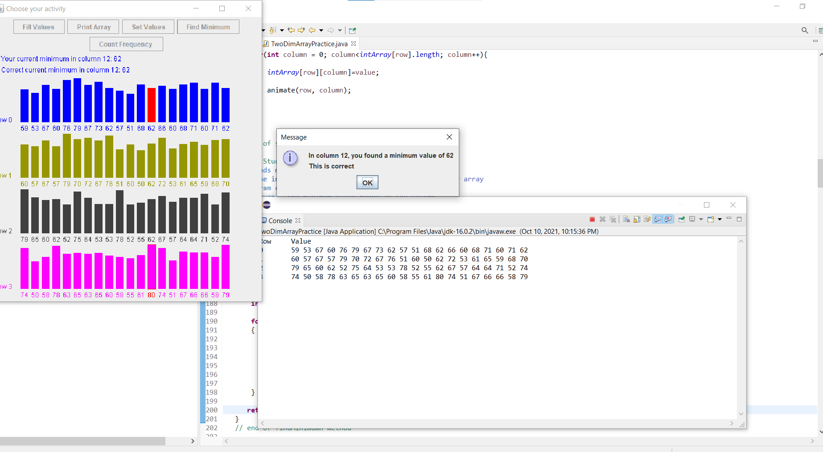

Task 4

